Assignment no-3

Name- Aditi Mondal

Course- Data Analytics

Submission Date- 29/6/22

1.What is the relationship among mean , median ,mode for right skewed and left skewed data?

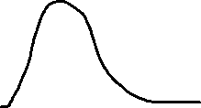

Right skewed distribution

In a Right skewed distribution mean will be greater than median and median will be greater than mode, so the relationship is mean(x bar) > median(M)> mode(m).As it is a right skewed distribution mean will be in right side of the distribution, median will be at some mid point and mode is that value which has highest frequency ,so from the graph we can say the tallest perpendicular on the x axis is the mode.

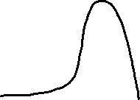

Left skewed data

For a left skewed distribution mean is the minimum than median and median is the minimum than mode, more precisely we can write mean(x bar) < median(M)<mode(m).As it is a left skewed distribution mean will be at left side, median at some mid point and mode will be that value which has the highest frequency we can see it from the above graph.